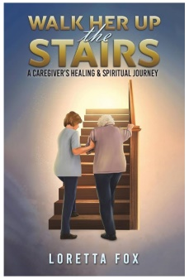**Discussion Questions for**

***Walk Her Up the Stairs: A Caregiver’s Healing & Spiritual Journey*   
by Loretta Fox**

1. Discuss the format of the book – a quote beginning most chapters and a poem concluding every chapter. Does this format work? Does it make the story more or less effective? Did you notice when the quotes stopped?

2. Do you have a favorite poem in the book? In what ways does the poetry speak to you?

3. Discuss the mother’s point of view. Do the quotes at the beginning of the chapters give a voice to the mother? Do you think that the mother would have embraced the thoughts that the author attributed to her in the poem *My Mother’s Thoughts (Maybe)*?

4. What was your impression of the mother prior to reading the Epilogue? In what ways does the Epilogue inform the book? After reading the Epilogue, do you feel differently about the mother?

5. What was your impression of the daughter/caregiver? Is it possible to know if she was doing the right thing by keeping her mother at home instead of placing her in a care facility, such as the inpatient hospice? Were her impatience, frustrations and fears justified?

6. What do you see as pivotal moments in the story? Can you imagine the ways things might have happened differently if other choices had been made throughout the lives of these two women?

7. At what points, including in the memories from the past, does the mother-child relationship change and alter? How do these changes affect the care relationship during the last months of the mother’s life?

8. The author states that the hospice workers are “carriers of daily miracles.” In what ways does the hospice team support the caregiver as well as the patient?

9. The author explains that this story shows her mother from the author’s own point of view, showing only their unique relationship, which was probably different from the way other family members and friends experienced her mother. In what ways do you find this in your own life? Do you find that you have experienced loved ones in ways that other people do not?

10. In what ways are the walks up and down the stairs important to the story? The walks happen literally, but in what ways are they also symbolic of the characters and the relationship? Is there a difference between walking up and walking down the stairs?